REGISTRATION FEE

Delegates from Industries: Rs.1,000/-
Delegates from Institutions: Rs.750/-
Students from institutions: Rs. 500/-

The registration fee includes complete course material, tea and working lunch.

The Demand Draft should be drawn in favour of “K.L.N. College of Engineering” payable at Madurai and mailed to the address given in the application form.
_______________________________

A Demand Draft of Rs. ____________
DD.No.____________________ dated _________________drawn on _____________________ is enclosed.

Date:
Signature of the Participant
_______________________________
IMPORTANT DATES

Last date for receiving the application:
21-09-2010
Intimation of acceptance: 22-09-2010

RESOURCE PERSON

Eminent Researchers from reputed institution like IISc, NIT, AIM, BIT etc will handle different sessions.

______________________________

IMPORTANT DETAILS

Faculty and Students of the Engineering Colleges / Polytechnics, Industries are eligible to apply.

Accommodation will be provided on payment basis subject to availability.

No TA/DA will be given.
_______________________________

MAIL TO

Dr. M.R. Thansekhar
Prof. P. Udhayakumar

Coordinators, RM 2010
Department of Mechanical Engineering
K.L.N. College of Engineering
Pottapalayam – 630 611
Sivagangai District
Tamilnadu
Mobile: 99409 65637 / 80561 92379
Email: rm2010@klnce.edu
Website: www.klnce.edu

Two Day Workshop

on

Research Methodology

September 24-25, 2010

Convener

Dr. S. Ganapathy

Coordinators

Dr. M.R. Thansekhar
Prof. P. Udhayakumar
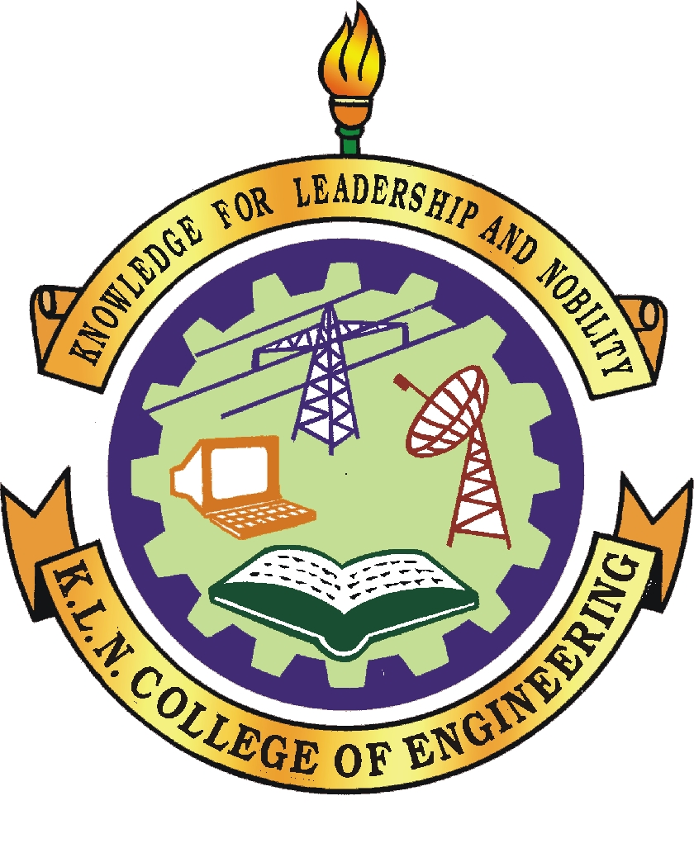

Organized by

Department of Mechanical Engineering
K.L.N. College of Engineering
Pottapalayam – 630 611
Sivagangai District
Tamilnadu

ABOUT THE INSTITUTE

K.L.N. College of Engineering is the first Self-financing Co-educational Engineering College in Madurai, started in the year 1994 by munificence of philanthropist and well wishers in Sourashtra community, which is a linguistic minority in Tamilnadu. This college is sponsored by a committee of eminent Industrialist and Academicians led by enthusiastic, educationalist and industrialist (Amarar) Thiru. K.L.N. Krishnan.
This college has been approved by All India Council for Technical Education, New Delhi and is affiliated to Anna University. The institution offers seven under graduate courses and five post graduate courses.

ABOUT THE DEPARTMENT
The Mechanical Engineering Department was started in the year 1994 and is accredited by NBA. The department offers one UG Programme (B.E Mechanical Engineering) and one PG (M.E CAD/CAM) courses. The department is well equipped with qualified and experienced faculty members with research background. The department contains well established laboratories to impart good practical training to the students.

RESEARCH METHODOLOGY

Research in common parlance refers to a search for knowledge. Research simply put, is an endeavour to discover answers to problems through the application of scientific method to the knowable universe. Method requires that ordering of concepts and propositions, procedures of selecting and analyzing evidence and modes of interpretation be public, communicable and ultimately connectable. All the methods used by social scientists in their fact finding mission constitute methodology. The study of methodology facilitates understanding of social scientific inquiry. Research methodology is the description, explanation and justification of various methods of conducting research.

COURSE CONTENT

* Research - Issues, Myths and Reality
* Research Methodology in Applied Modeling Research
* Funded Research
* Research Tools
* Product / Process Innovation through TRIZ

REGISTRATION FORM (RM 2010)

1. Name:
2. Designation:
3. Mailing Address:

Contact No.:
Email ID:

4. Educational Qualifications:

5. Experience:

6. Motivation for attending the course and future plans:

7. Name of the College/University:

8. Signature and Date:

